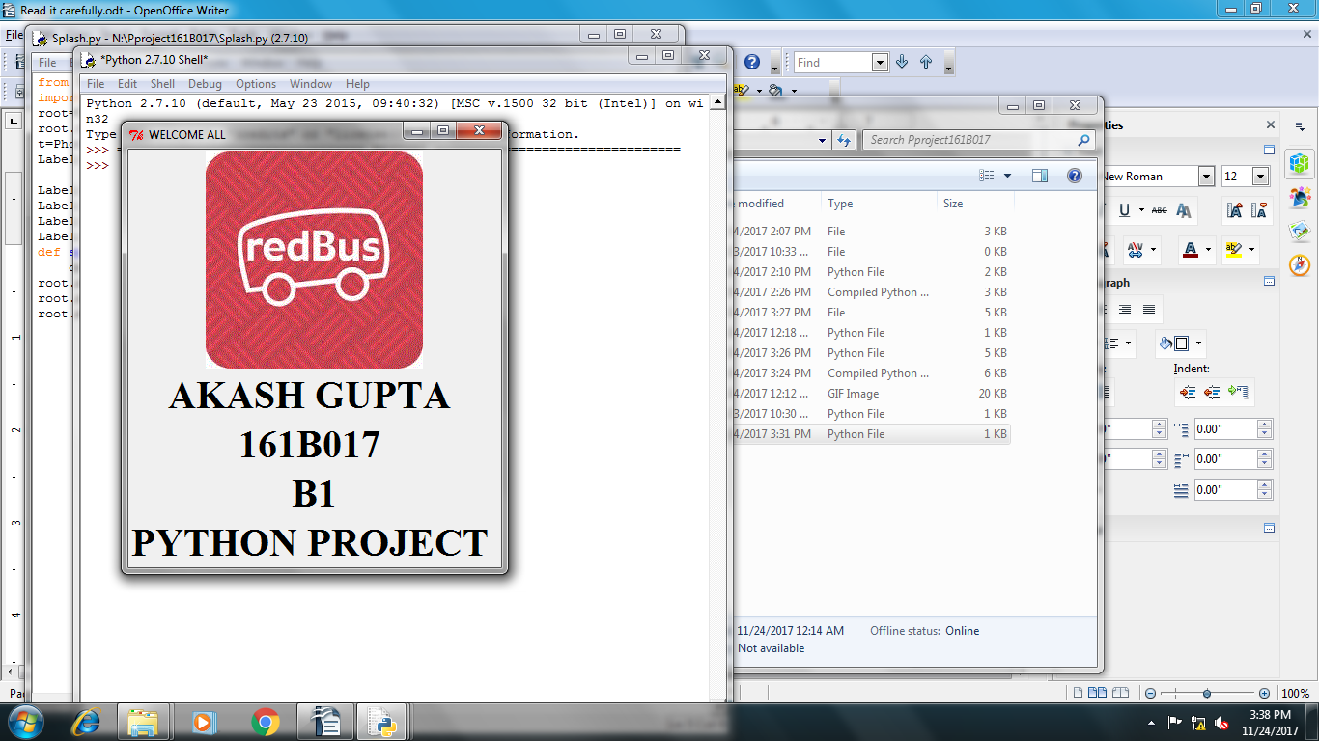

1.Splash Screen
The Project Will Run after the user will click on splash.py file, after which the splash screen will occur,user need to wait for a moment,after which login window will appear on screen.

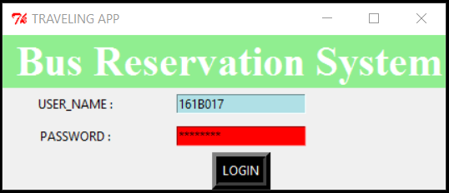
2.Login Window:
This is login window in which user need to put his username and password,there is prestored username:"161b017" and password : "password" so the user need to put this particular detail,presently there is no option for sign up registration,it will be added further.
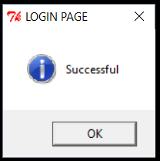

- Message Box:
This Message indicates that you successfully logged in and can proceed further.

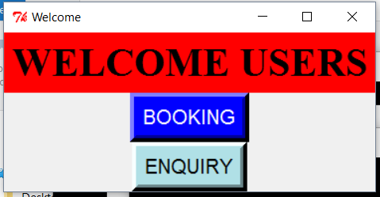
4. Booking/Enquiry window:
This window appear after the login window which provides user two options "booking" option is for user who haven't booked any ticket yet and wanted to book a ticket and "Enquiry" option is for users to enquiry about their booked ticket.

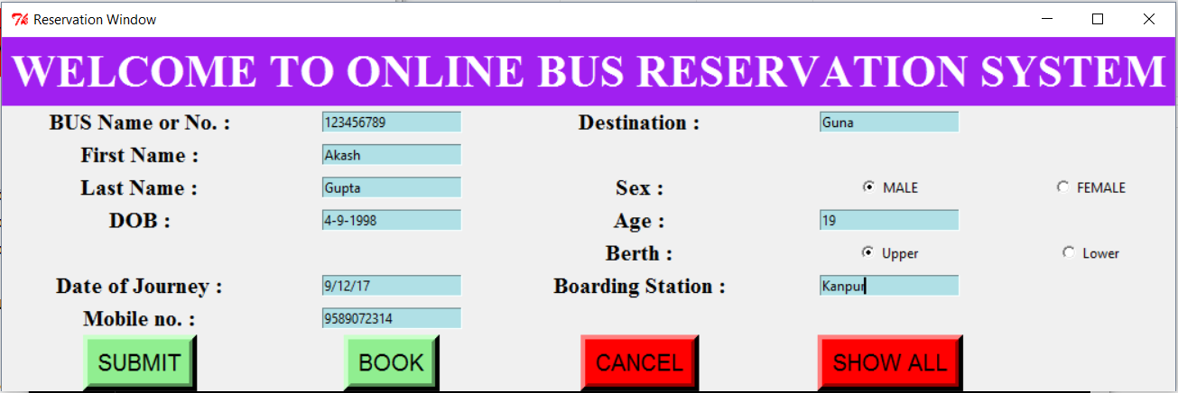
5.Booking option:
When user click on Booking option this window appears in which user need to fill all the required detail in Entry box and then click on submit then you will get the details of the respective user and then on clicking on Book button user will get the seat no. On providing the bus no. And if the uiser clicks on "Show all" window he will all the details including the seat no.

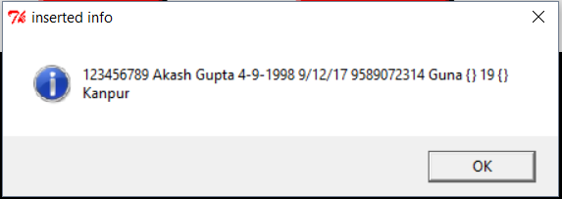
6.Confirmation window:
On clicking the submit button you will get a confirmation window of successfully receiving the details of the user.
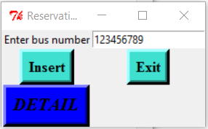

7.Seat allotment window:
when user enters the bus no. And click on detail after clicking on insert the alloted seat number will be shown to him.

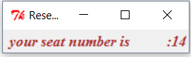
8.Confirmed Alloted Window:
Such window appears on screen which shows the alloted seat no. Of the user.

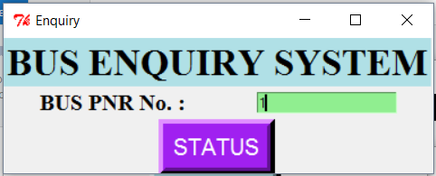
9.Enquiry Option:
If the user clicks on Enquiry option,he is provided with this particular in which user need to put the PNR no. Of the bus and he will get status of bus. User need to keep in mind that the predefined PNR no are ex. 1,2,3,4,5,6,7,8,9,10 out of these any of the PNR only should be entered.

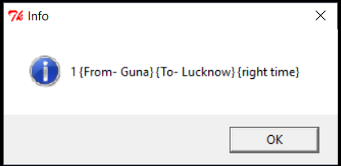
10. PNR info:
On providing the PNR no. This window will appear showing the details of the bus including the route of the bus.

